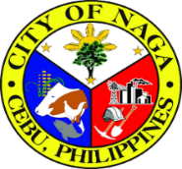
Republic of the Philippines
Province of Cebu
City of Naga
OFFICE OF THE CITY MAYOR
CERTIFICATION
To Whom It May Concern:
Based on the document presented to this office by @name, a resident of @address City of Naga Cebu, namely Affidavit of Guardianship, Barangay Certification of Indigency, and Bureau of Internal Revenue (BIR) Affidavit that above name is not required to file an Income Tax Return, @lastname have no income/low income to support the education of his @relation, @child.
This Certification is issued upon the request of @lastname in compliance to the requirements of the participation of his @relation in the ESC Scholarship Grant at @school.

Issued this @day day of @month, at @address City of Naga Cebu, Philippines.
 |  |  |  |  | KRISTINE VANESSA T. CHIONG
 |  |  |  |  |  | City Mayor
 | Not Valid without Official Seal
 | Reference No. | @ref_no

